PROJECT DONE BY M.MALATHI

INVENTORY MANAGEMENT

|  |  |  |
| --- | --- | --- |
| PARTICULARS | DEBIT | CREDIT |
| CAPITAL |  | 400000 |
| ROYALTY PAYABLE |  | 70000 |
| CASH | 120000 |  |
| BANK O/D |  | 50000 |
| ICICI BANK | 80000 |  |
| BILLS PAYABLE |  | 20000 |
| FURNITURE AND FITTINGS | 50000 |  |
| BILLS RECEIVABLE | 50000 |  |
| LAND AND BUILDINGS | 60000 |  |
| LOANS (UNSECURED LOANS) |  | 10000 |

STOCK IN HAND

SONY TV 15 N0S 5500

SONY I PAD 15 NOS 500

LENOVA LAPTOP 7 N0S 12000

MICRO MAX 8 NOS 2000

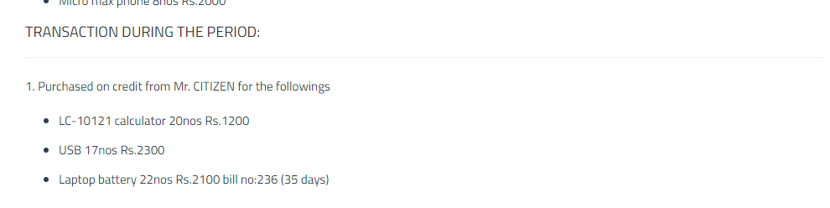

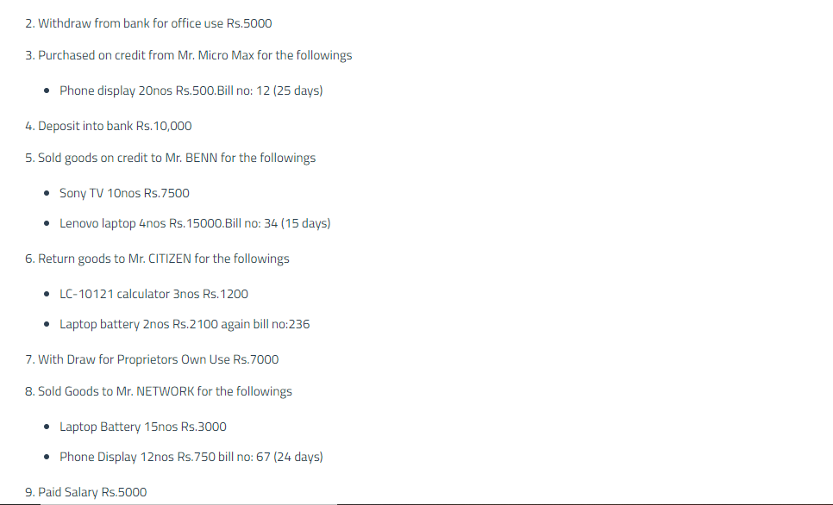



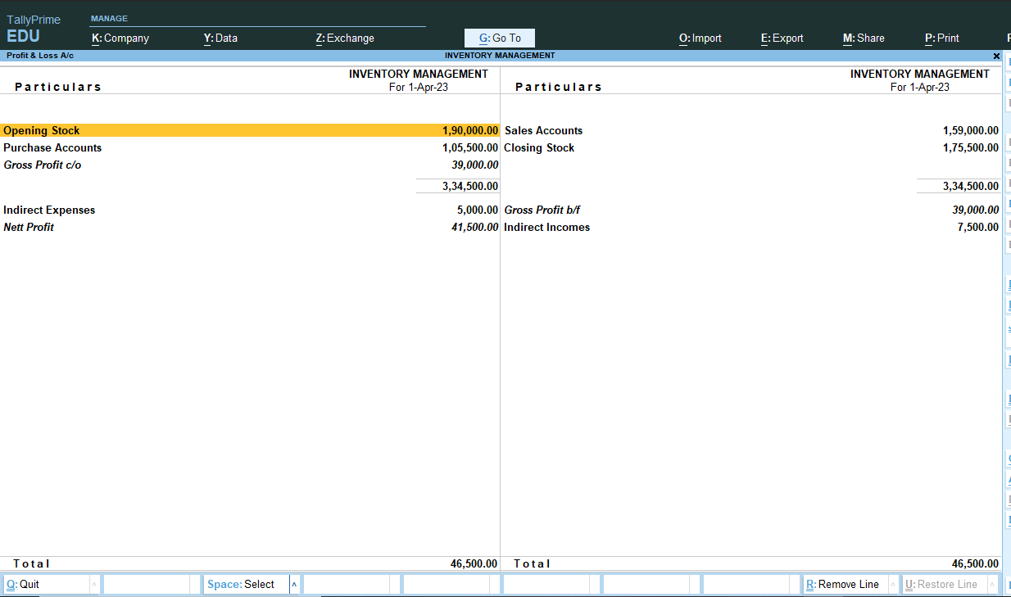

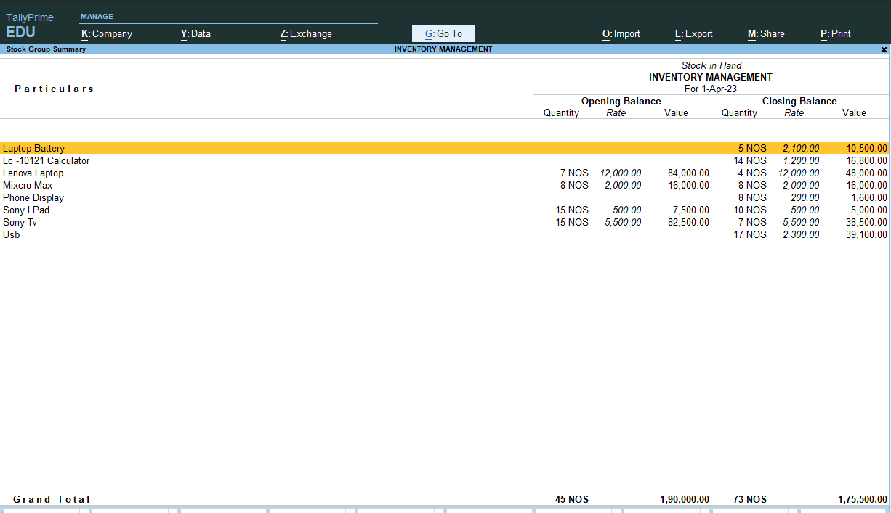

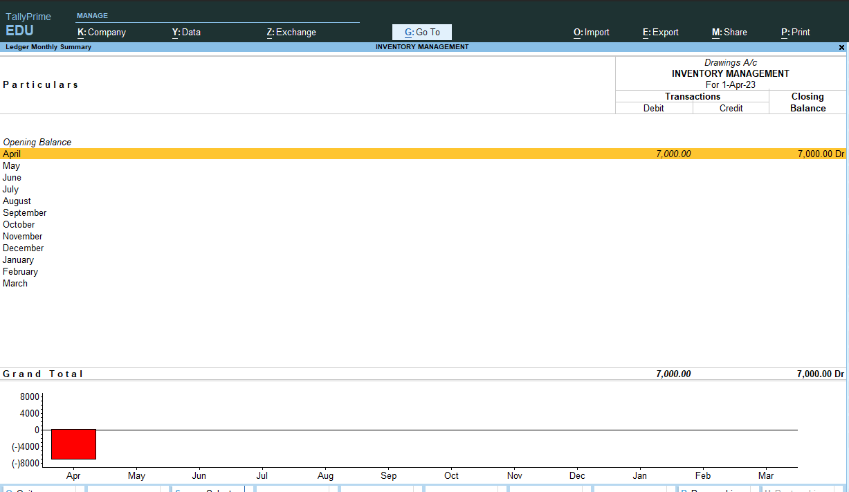

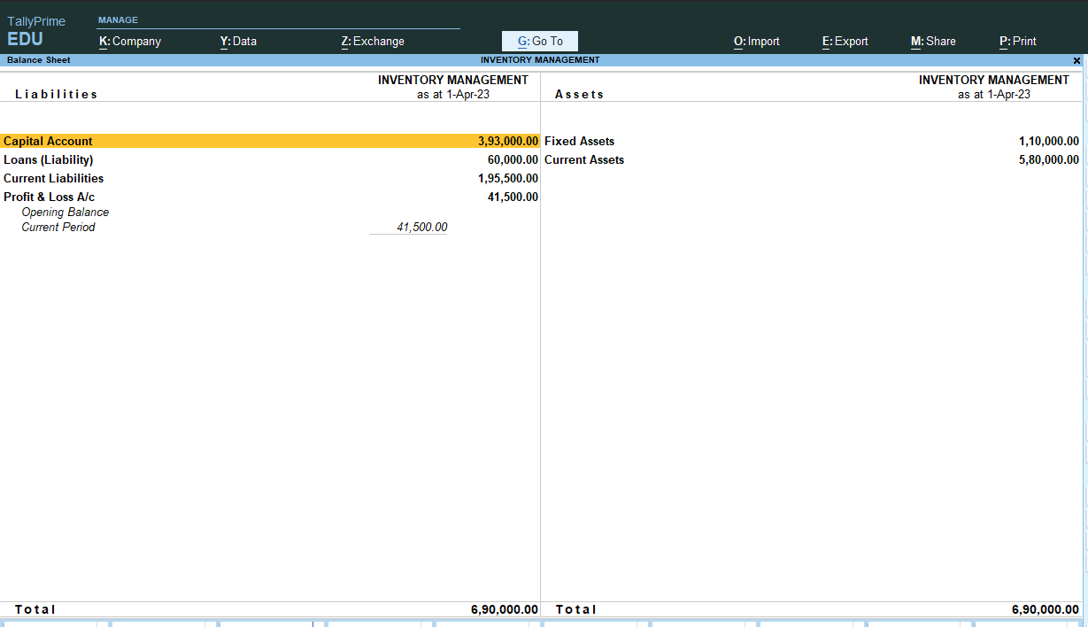

INVENTORY PROJECT COMPLETED